Ollada, Janezza Mariclaire

Oracrew

**Klima Pythia Analytika**

**A Weather Prediction Model for F1 2021 video game**

|  |
| --- |
| **#FormulaAI Hack 2022** |
| **Challenge 1: Data Analytics** |
| **February 2022** |

|  |
| --- |
| Lorenzana, Per Cristina |
| De Las Alas, John Cedrick |
| Delmo, Jason |
| Ollada, Janezza Mariclaire |
| Alcayde, Kathleen Marie |
| Alito, Jennifer |
| De Guzman, Celine |
| Podpod, Joven Glory |

Table of Contents

Introduction 2

Problem Definition 2

Scope 2

Purpose 2

Proposal 2

Design and Implementation 3

Algorithm 3

Data Sets 3

Conclusion 3

# Introduction

Formula 1 is one of the world’s most competitive extreme and data-driven sport. Data-driven because before and during a race competition, race engineers, and technicians will make strategic decisions based on data analysis and interpretations. F1 experts uses historical data for performance statistics, race prediction, weather predictions, and even insights for the spectators. But how can weather conditions affect these types of activities? Let us give you an insight about our proposed product.

This document will focus on how our product was made and what benefits can our customers guarantee from using this dashboard. This product will focus on all individuals including video game players and non-video game players. This product can be ideal to use by every individual and we believe that this is the best part of our solution.

# Problem Definition

F1 2021 weather conditions are also compared to real-life situations. In short, the actual weather of one’s place is also reflected in the exact location and time of the game. Non-video game player checks the weather condition before executing their plans/schedules, while a video-game player checks the weather condition of the gameplay before choosing a selection of cars and characters to be used.

# Scope

The aim of the study is to provide accurate weather predictions that can reduce each organization and individual's financial and economic losses. We believe that this will be beneficial to all non-players and players for F1 2021. This will also cover all physical activities, not just F1 Racing.

# Purpose

The purpose of the product is to provide answers on what will be the weather condition for the next minutes hour, or even day. We also seek to advise all users that checking weather conditions is a must and must be part of one’s priority as this will also be a factor that may affect their day or plans. We also aim to provide a 100% stress-free environment when using this product which is suitable to use by all ages.

# Proposal

Klima Phythia Analytika is a user-friendly dashboard that allows the user to see and get accurate details of rain, temperature, and even humidity. Predictions of this dashboard are also relevant to video game players as the results are the same as the conditions outside. We believe that game performances are very important to our players so we created an analysis where they can also check the prediction for the next hours. In that way, they can have a selection of materials that they can use to prepare for the game. Just like in the real world, before executing their actions, our users can manage to create informed decisions that will somehow benefit their lives.

We want to feel our customers that even though they are focused on the game, they can still feel the presence of the outside world. We want to create an impact on all customers, and we feel that putting an alarm system on this dashboard may also benefit them every day. We want to extend more and create bigger than this single dashboard. We are proposing to create an analysis that will also let the users have an awareness of different weather conditions such as typhoons, floods, and even winter storms. With the power of Oracle, we can feel that we can innovate more and improve this solution to provide a better experience not just to players but to all individuals.

# Design and Implementation

## Algorithm

To identify the algorithm to be used, 80% of the data set was trained using different models to get the highest accuracy.

Rain percentage:

|  |  |
| --- | --- |
| Algorithm | Negative Mean Squared Error |
| Support Vector Machine (Linear) | -29.7163 |
| Neural Network | -16.5369 |
| Generalized Linear Model (Ridge Regression) | -15.7427 |

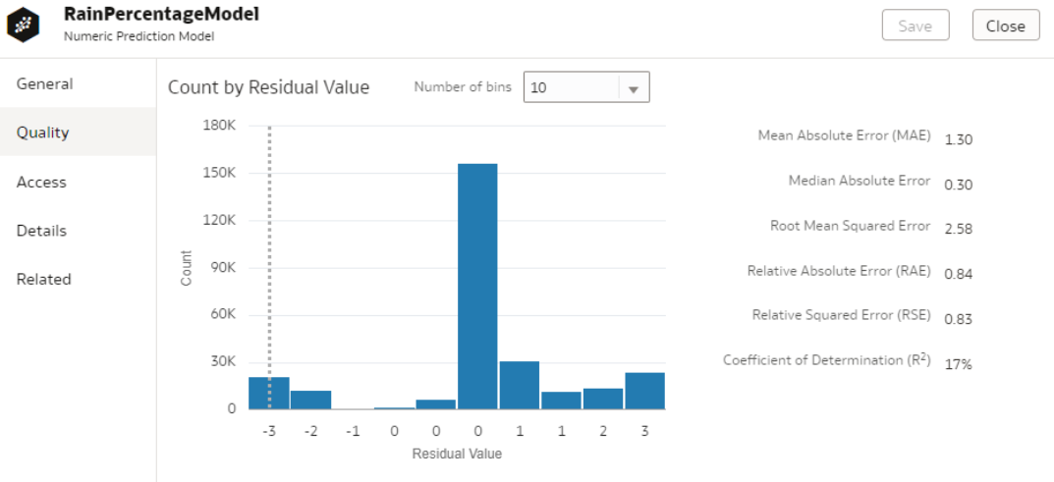

Based on the above results, the Support Vector Machine (Linear) algorithm was applied to get high accuracy results for Rain Percentage.

Classification of Weather:

|  |  |
| --- | --- |
| Algorithm | Accuracy |
| Neural Network | 90% |
|  |  |
|  |  |

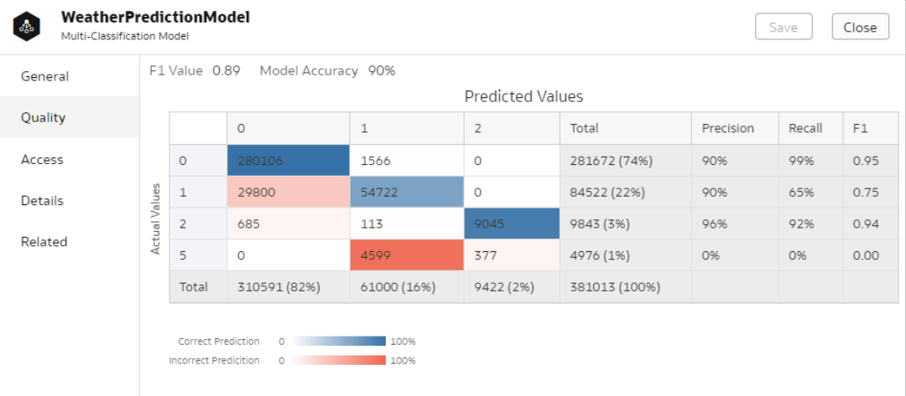

Based on the above results, the Neural Network algorithm was applied to get high accuracy results for the Classification of weather.

## Data Sets

The data set used for the solution that we’re proposing was provided by the Formula1 Team. We decided to divide dataset files to three(Testing, Training_pt1 and Training_pt2) . We also decided to clean the data by removing some of the attributes and null values.

Sample UI and Business Model

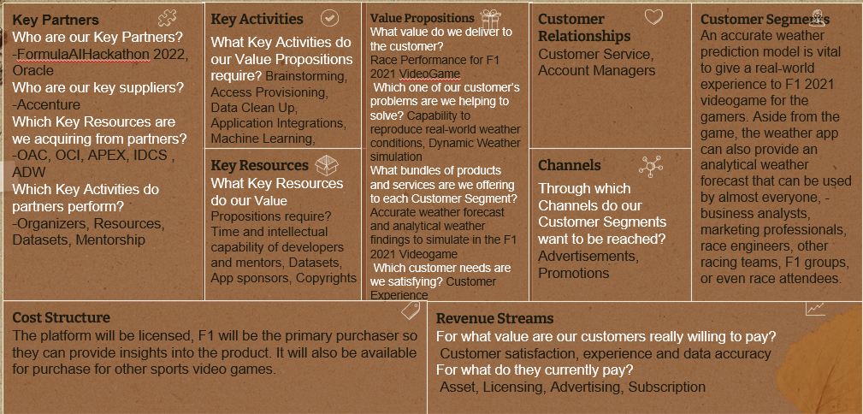

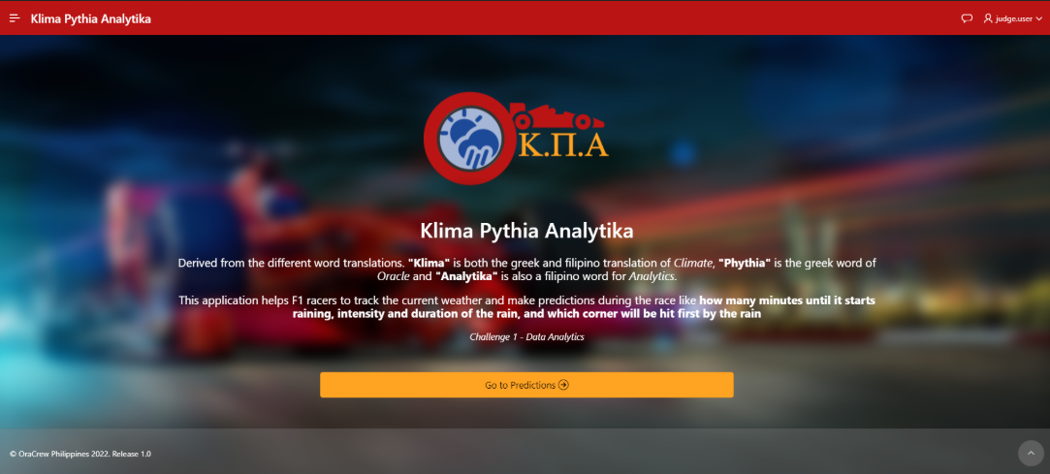

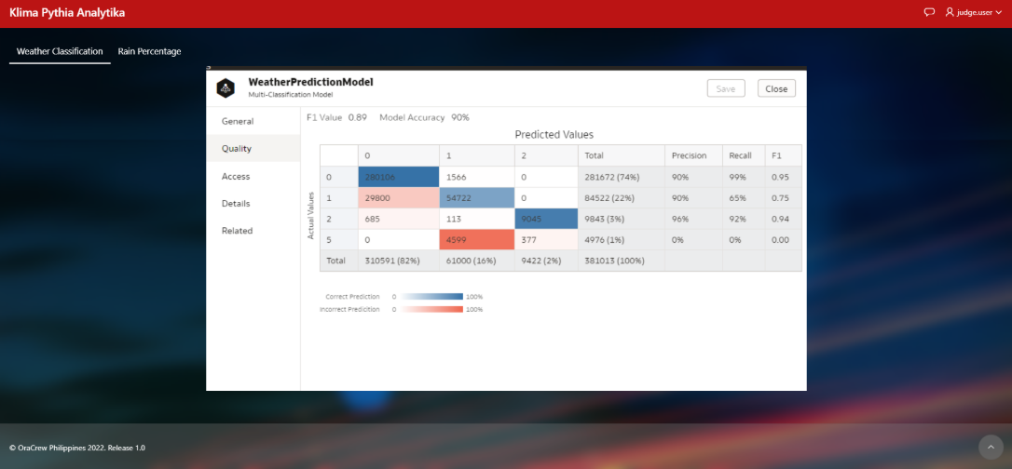

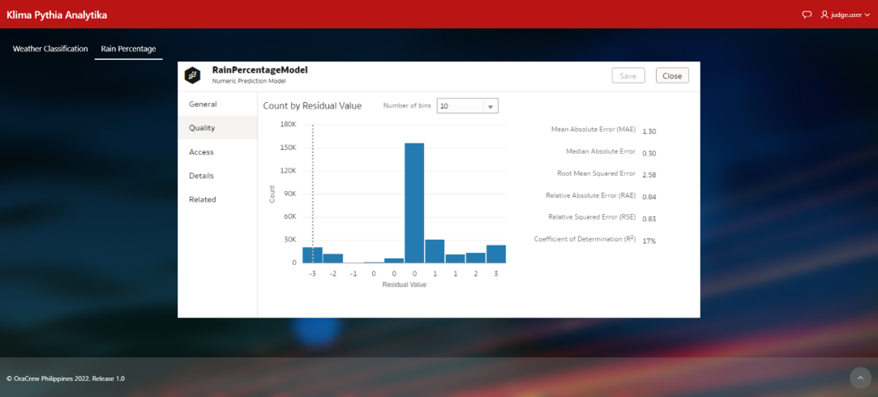

Unforeseen events are terrifying. You’ll never know what you can lose if there are phenomenon’s that will eventually occur.And you'll realize, why was not this recognized?

Imagine doing an outdoor activity, like fun-run , then suddenly a storm came.

Imagine you have an event that includes car racing, when suddenly the track was flooded by rain in the middle of the game. What do you think will happen?

So before you carry out activities, you should think bigger and be prepared for this type fo circumstances.

ClimaCast is a weather forecast analytics dashboard that allows users to see the current state of the atmosphere at a given place. This includes the temperature, humidity, precipitation, and even location where the rain will start.

Let's say a user has a race for the next hour and have checked through the dashboard that it will be rainy, the user will have a chance to plan and have multiple selections to prepare for racing and set up the materials that you need in order to get positive race performance.

*Insert how this dashboard was created*

*Insert how you were able to come up with the result of the report*

It's simple as that, the user has a scheduled race, the team will check the weather, they will gather the selection of tires to use. Very efficient. Very reliable.

Using the power of Oracle, OCI adn APEX we became more innovative which makes this solution enormous. This doesn't just benefit that user on a single outdoor activity, This is also applicable to Hiking, fun-runs, jogging, skiing, or many more.

So, if you're seeing this right now, act fast, get this solution right now, and be confident in all your activities.

We also want to share the team that made some effort on this solution ,

Thanks everyone!